**DOG MISSING**

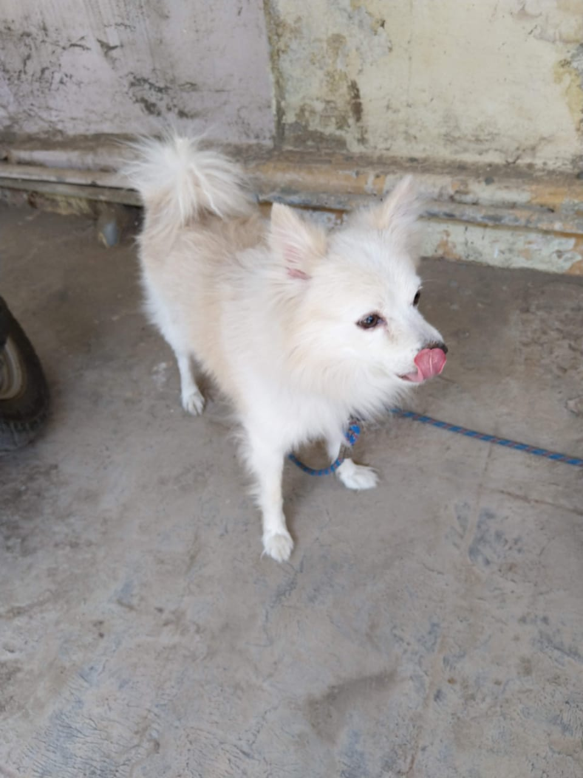

Name of Dog: SCOBBY (MALE)

MISSING FROM NANDI RAILWAY OFFICERS COLONY, GANDHI NAGAR,

SINCE 26.08.2019/08.00 HOURS

Breed: pomeranian/WHITE

Contact Info: 9449905074, 8147574179, 8904818202

FINDER WILL BE SUITABLY REWARDED